**TxtWeb AI Project Presentation**

***1. Aim of Project***

TxtWeb AI transforms natural language descriptions into fully functional, responsive websites in seconds, eliminating the need for coding skills and making web development accessible to everyone.

***2. Modules***

**Authentication Module**

* **Components**: auth.js, auth.html, auth.css
* **Functionality**: Handles user registration, login, and session management
* **Features**: Email/password authentication, Google sign-in integration, user profile creation

**Dashboard Module**

* **Components**: dashboard.js, dashboard.html, dashboard.css
* **Functionality**: Manages saved projects and user settings
* **Features**: Project grid view, preview functionality, project management actions

**Website Generation Module**

* **Components**: main.js, Flask backend API
* **Functionality**: Processes text prompts and generates website code
* **Features**: AI prompt analysis, HTML/CSS generation, responsive design creation

**Preview Module**

* **Components**: index.html, style.css
* **Functionality**: Renders generated websites in real-time
* **Features**: Responsive testing (mobile/tablet/desktop views), code preview

**Database Module**

* **Components**: Firebase integration, database setup scripts
* **Functionality**: Stores user data and project information
* **Features**: Real-time data synchronization, document-based storage

***3. Algorithms***

**Text-to-Website Generation Algorithm**

1. Parse user text prompt for keywords and intent
2. Determine website structure based on prompt analysis
3. Generate HTML skeleton with semantic structure
4. Apply CSS styling based on identified theme/purpose
5. Implement responsive design patterns
6. Optimize code for cross-browser compatibility

**User Authentication Flow**

1. Validate user credentials against Firebase Authentication
2. Create/retrieve user document in Firestore
3. Initialize user settings and preferences
4. Establish secure session with Firebase token
5. Route to appropriate application view

**Project Management Process**

1. Create unique project IDs for database storage
2. Store project metadata and generated code
3. Implement CRUD operations for project handling
4. Maintain version history and modification timestamps
5. Enable export functionality for generated code

***4. Sample Coding***

***5. Sample Screenshot  
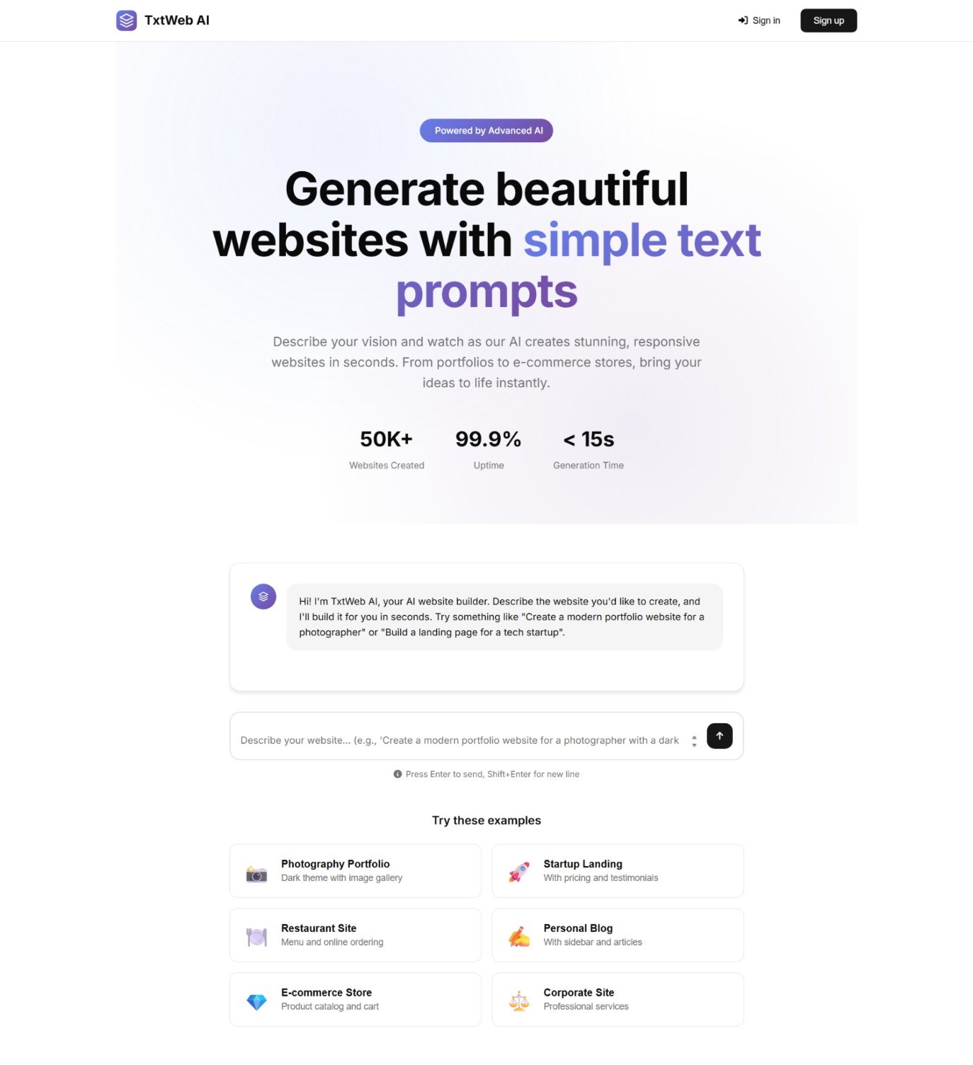***

***6. Future Enhancements***

**Advanced AI Integration**

* Implement specialized AI models for different website categories
* Add support for industry-specific design patterns and templates
* Integrate image generation for custom visual assets

**Enhanced Customization**

* Add post-generation visual editor for fine-tuning designs
* Implement component library for drag-and-drop customization
* Create theme customization system with color palette options

**Expanded Export Options**

* Add export to WordPress, Shopify, and other platforms
* Implement static site generator integration (Jekyll, Hugo)
* Create deployment pipeline to popular hosting services

**Collaboration Features**

* Enable team workspaces for collaborative website building
* Add commenting and feedback system for design reviews
* Implement version control for project history

**Analytics & SEO Tools**

* Add SEO analysis and optimization suggestions
* Implement performance scoring for generated websites
* Create analytics dashboard for deployed sites